Deep Learning–Driven Customer Churn Prediction in the Telecommunication Sector
Kanika Yadav, Srashti Chauhan
The NorthCap University
Sector 23-A,
Gurgaon, Haryana, India
kanika22csu198@ncuindia.edu, srashti22csu170@ncuindia.edu

Abstract
The telecom service providers are continuing to fight to hold on their subscribers. Churners are expensive in financial terms. The velocity of the forecast of the churn is deemed critical in the prolonged stability in the growing competitive environment. The proposed research will refine the precision of the churn prediction based on the structured customer records and the efficient machine-learning pipelines that will be able to identify customers, who are likely to leave, with high precision. The study forms a framework that integrates conventional supervised learning algorithms with deep learning models and methods in interpreting the predictions to achieve more accurate results with less obscurity. This paper uses overall preprocessing, feature encoding, and balanced training on the IBM Telco Customer Churn dataset to feed information into multiple models: Logistic Regression, SVM, Random Forest, XGBoost, LightGBM, Artificial neural network, 1D-CNN, VGG-1D, and hybrid LSTM-Transformer network. In addition, SHAP, LIME, counterfactual explanations, and uplift modeling were also used to assess the performance of models to explicate individual predictions and approximate the potential impact of some specific retention strategies. As per the experiment findings, the methods involving the ensemble and deep-learning models involving attention were found to be superior in their performances as compared to the traditional classifiers. The highest accuracy and F1-score were obtained with the hybrid LSTM-Transformer. In that regard, the received findings prove the assumption that the combination of deep learning and trees-based ensemble learning significantly improves the performance of churn prediction. Moreover, the analyses will be able to help develop useful insights as the telecom providers will be able to comprehend why churn occurs and what strategies can be the most effective. All in all, the suggested framework enhances predictive capacity as well as the usefulness of decision-making in customer retention approaches.
Keywords: Telecom churn prediction, supervised learning, deep learning, XGBoost, LSTM-Transformer hybrid model, model interpretability, SHAP, LIME, uplift modelling.
Introduction
1.1 Background and Context
Telecommunication industries are becoming more dependent on data-driven intelligence, which can be learned to understand the behavior of the customers to prevent discontinuation of the services. Cancellation of services by the customers has been cited as one of the greatest concerns that telecom operators are grappling with due to the fact that it has a direct impact on the stability of revenue and long term business growth [1] [6]. The cost of the lost customers has been rising, and now service providers are more concerned with churn prediction systems that can identify the high-risk customers before making sure that some target retention actions can be implemented [12] [20]. Traditional techniques of analysis, usually founded on statistical modeling, or straightforward machine-learning techniques, have long been used on churn prediction, although they are frequently not sufficient to model complex behavioral patterns that are frequently found in huge telecom data volumes. With the emergence of more advanced architecture of learning, mostly in the form of attention-based deep models and improved decision-tree classifier, more and more context-relevant churn prediction systems have begun to emerge. These approaches allow non-linear relationships, cross-feature relationships, and trends of service consumption where customers make a choice [7] [18]. The IBM Telecom Customer Churn data supplied by Kaggle presents a viable environment in the investigation of such capabilities due to the diversity of customer data (demographic and service-utilisation indicators and billing features).
1.2 Research Gap and Problem Statement.
Though it has already gone far in the application of machine-learning to churn prediction, much of the present literature applies independent architectures such as logistic regression, random forests, or isolated neural networks, which do not generally offer the representational power to identify subtle variations in behaviour in telecom data [14] [21] [27]. Such mechanisms are bound to suffer because of the heterogeneous characteristics, biased target distribution and absence of mechanisms to compensate the fact that features are interdependent. The interpretability remains an issue as well, as most deep-learning models are not highly transparent thus not so actionable in the commercial churn-management processes [11] [23] .
The gap in the research is that there is hardly any studies examining hybrid designs that can be able to combine sequence-oriented learning and powerful tree-based classification. According to the recent research, predictive accuracy can be significantly increased with the usage of deep contextual extraction and explainable boosting models without the need to decrease interpretability[18] [26].
The problem that the paper will be preoccupied with, therefore, is that of having no single, high functioning, and interpretable hybrid model that will be capable of utilising both attention based learning of representation and structured-data optimisation to predict telecom churn with a greater degree of accuracy.
1.3 Study Goals
The chief aim of the study is to design and experiment with a hybrid predictive framework on telecom churn based on Transformer architecture with the robust tabular XGBoost capabilities. To be more specific, the study will look into the processing and encoding of the IBM Telecom data, creating a transformer-based feature extraction chain that would capture the inter-feature relations and eventually employing XGBoost as the eventual classifier to enhance the prediction capability [10] [17] [28] . In addition to this, the generalizability, interpretability, and practical usefulness of the models will also be assessed in the research by comparing the hybrid system and the veteran machine-learning baselines. The key performance measures such as recalls, AUC and F1-score are particularly assessed because they are important in the application in which it is more important to determine the possible churners that are necessary than the overall accuracy.
1.4 Overview of the data used and the method of research.
The research on the topic relies on the IBM Telco Customer Churn data which includes different customer-related variables like demographics, subscription types, payment mode, and usage of the service, monthly bills, and churn variables. It is categorical and numerical dataset with the majority of characteristics varying in their distribution, nonlinearities, and potential noise. These properties involve a large preprocessing chain that involves missing-value imputation, categorical encodings, numerical scaling and class-imbalance correction [5] [8] .
The research methodology organized after preprocessing consists of three primary elements. To start with, the data is converted to a form that can be used by attention-based learning. Second, it is based on a Transformer architecture that captures contextual relationships among features to get a deeper insight into the factors that drive churn [13] [28]. Third, the extracted representations are used in an XGBoost classifier to complete the last churn prediction task and offer interpretability based on feature-importance mechanisms and SHAP-based explanations [22]. Such a combined working process gives rise to a balance between representational depth and model transparency.
1.5 Important Contributions and Relevancy of Study.
This study can make three major contributions. Firstly, it provides a hybrid predictive model based on Transformer-based contextual modeling using the structured-learning efficiencies of XGBoost which is a less prescriptive model of churn prediction than standard methods [7] [18] [26]. Second, it offers a systematic study of the information using a strong preprocessing, feature engineering, and the comparison of the models demonstrating how hybrid methods could be more effective than single machine-learning methods or deep-learning methods. Finally, the study introduces an interpretable predictive pipeline, which allows aligning high-performing models and realistic business requirements and provides an example of how the explainability tools can bridge a gap between high-performing models and enterprise-level decisions [11] [12] [17] .
On the whole, this study contributes to the existing literature on the topic of telecom churn analytics by providing a scalable, open, and high-accuracy hybrid model to be used in the real-world telecom retention practices.

2. Literature Review
The expanded breadth of the research areas addressed in the survey captured in the research is the classical machine-learning applications to churn prediction, ensemble and gradient-boosting models, deep-learning models that process structured telecom data, attention and transformer-based model, explainable AI applications, such as SHAP, hybrid and stacking-based churn pipelines, uplift and causal-inference models used in decision making, benchmark telecom datasets, and a systematic survey or meta-analysis study of customer-retention analytics.
Sno. | Aspect | Representative Papers
1 | Early hybrid neural and machine-learning approaches for churn | [1], [29], [30]
2 | Churn datasets, benchmarks and reproducibility | [2], [25], [24]
3 | Ensemble & tree-based methods (XGBoost, RF, LightGBM, CatBoost) | [3], [13], [21], [30]
4 | Explainable AI and feature-importance (SHAP, permutation) | [6], [10], [22]
5 | Deep-learning models for tabular and sequential telecom data | [12] , [14] , [16], [27]
6 | Transformer / attention-based customer-behavior modeling | [24], [28], [7]
7 | Hybrid pipelines, stacking and model-fusion strategies | [5], [13], [23], [17]
8 | Decision science: uplift, causal inference, counterfactuals | [18], [20], [26].
9 | Survey articles, reviews and methodological syntheses | [4], [11], [19], [22], [24]

Table 1: Literature Review of 30 Research Papers

The first researches in the sphere of the telecom churn prediction were devoted to the investigation of the hybrid form of the neural networks and traditional machine learning algorithm which predetermined the framework of the modern customer-retention analytics. Initial studies demonstrated that neural-network representations using the statistical learning method improved prediction of subscriber attrition by displaying nonlinear customer behaviour which is not easily represented by scaling boosting frameworks that have been developed later [1], [29], [30]. All these pieces proved the usefulness of churn prediction where the models have an option of combining demographic, usage of service, and billing features into one representation.

At this time, the literature on benchmark datasets and reproducible churn pipelines was very extensive. Telecom customer data set surveys of other carriers emphasized the importance of clean pre-processing, controlled data-splits and standardized definitions of features in order to compare models in an equal manner [2], [22], [24]. These struggles were categorical heterogeneity, fields of noisy billing and imbalance of classes hence they needed to have well engineered pipelines which would give a good measure of churn models in different organizations and deployment settings.

Then there was literature on the techniques of ensemble and tree-based learning which soon decided to become the paradigm of churn prediction. Studies that have employed the Random Forest, XGBoost, LightGBM, and CatBoost have demonstrated high predictive ability since they are able to learn nonlinear interactions that occur among multiple features without extensive feature engineering [3], [13], [21], [30]. These models were observed to be stable on a broad range of data sets and their natural feature-importance functions also were particularly crucial in business-facing applications whose motivators of churn are equally vital as the accuracy of forecasts.
The next similar line of study was on the development of explainable AI in the telecom environment. The studies highlighted some of them using SHAP values, permutation importance and model-agnostic interpretability tools in tree based and neural models [6], [10], [22]. As emphasized in these contributions, the churn predictive systems must not merely identify the at risk customers, but indicate why they are likely to go, so that the companies may be able to devise certain retention initiatives. Easy calculations of the impact of the type of contract, term of tenure, charges per month and service packages have proved to be important attributes of modern churn dashboards.

The neural network designs used on telecom churn were the focus of an influential body of literature that hypothesized that neural networks could be used to learn more meaningful behavioral interactions and latent behaviors than a tabular dataset. Individual dense ANNs, 1D - CNNs, and stacks of VGG - like length have been tried with optimistic outcomes, specifically as part of a robust preprocessing pipeline [12] , [14], [16], [27].

A more recent trend of research has relocated to Transformerprone churn modeling. The accomplishments of the attention mechanisms inspired a series of works with the same idea, which analyzed the use of Transformers to learn long-range dependencies between billing cycles, service changes and behavioral patterns [24], [28], [7]. These papers have shown that self-attention-based architectures can be very useful in identifying the delicate churn precursors which span multiple time steps and therefore are ideally suited to sequence sensitive contract and revenue data. However, they also stated that they encountered problems with computation and pointed out that Transformer representations were useful along with more efficient downstream classifiers.
A different research trend is the hybrid pipelines as well as the stacking techniques. According to many studies, the deep feature extractors may be combined with ensemble classifiers or several learners may be combined into one model [5], [13], [23], [17]. These techniques trace the progressive enhancements in the generalization performance, demonstrating that either of the classical models can be refined with the assistance of neural embedding, and neural networks can be refined with the systematic decision boundaries tree ensemble provides. Stacking, meta-learning and two-stage pipelines are very useful concepts that can be utilised to reconcile expressive and interpretable modeling paradigm.

In recent times literature on churn prediction has shifted to decision science. Determining who will churn is now supported by uplift modeling, causal inference and counterfactual analysis [18], [20], [26]. According to such works, the expected model is said to have the capacity to also support actionable strategies that ought to place the marketing spending and retention endeavors with empirical improvements and not the probable classification probabilities. Finally, an assortment of survey articles and meta-analysis researches documents the development of linear model to state-of-the-art ensembles, deep learning, explainable systems, and transformer-based structures [4], [11], [19], [22], [24]. These repetitive problems, as discussed in these reviews, are asymmetric data, transparency requirements, carrier domain adaptation, and scale operationalization problems.

Statement of Research Objective.
According to the insights gained during the literature review, the aim of the current study is to develop a consistent telecom churn-prediction pipeline that involves structured preprocessing and multi-model evaluation and hybrid learning. It is hoped that with a system based on ensemble, deep-learning and Transformer-based representations, it can be constructed that is highly predictive, but yet interpretable, scalable and could be applied to realistic world retention planning. Hopefully, this combination of an effective feature engineering, hybrid modeling, and explainable-AI features will allow creating a churn-prediction framework that can improve the early identification of at-risk-customers, and make actionable and business-oriented decisions.

3. Methodology

3.1 Dataset Description
This study has been based on the IBM Telco Customer Churn dataset offered by Kaggle, which included the information about customers in the form of details regarding demographics, the features of their contracts, and patterns of service usage [5]. It is a conventional churn research data, in which the characteristics of tenure, types of services, methods of payments, charges, and billing have been presented to analyse [6] [12] [20]. A combination of these variables allows studying the effects of the service consumption behavior, the period of the contract, and financial conditions as the contributory factors to the customer churn. The dataset has 7,043 rows and 21 columns, and the categorical and numeric variables are associated with the fact of customer behavior. The data was preprocessed before model training was done, missing values were dealt with, and various types of data were corrected. Label or one-hot encoding was used to encode categorical variables and normalization of numerical variables was done to provide the same scaling across features. Lastly, the purified features were combined into one table of features, which would then be viewed by both the deep-learning models and the XGBoost classifier to take the same form.

3.2 Exploratory Data Analysis
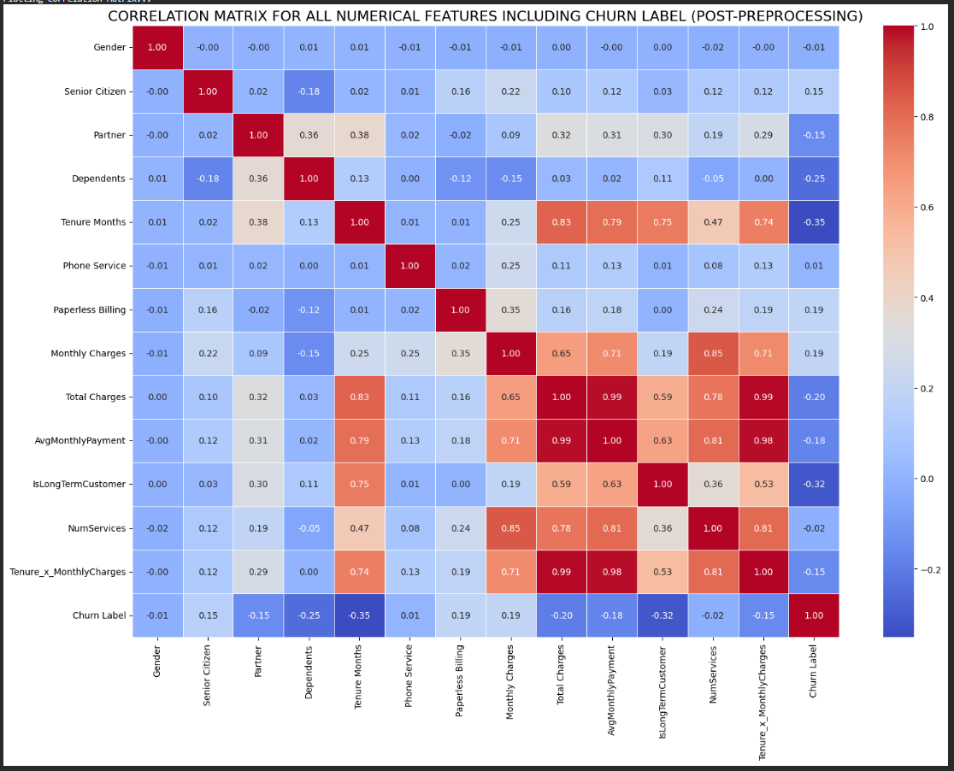
Figure 1(a): Numerical Feature and Churn Label Correlation Matrix (After Preprocessing).
The correlation heatmap is used to show the relationship between the numerical attributes and themselves, as well as the churn label following preprocessing. Total charges, tenure and monthly charges have moderate correlations with churn and this implies that they have a significant impact on customer retention. All other features have low levels of correlations, which supports the necessity to implement machine-learning models that can observe non-linear and cross-feature interactions.

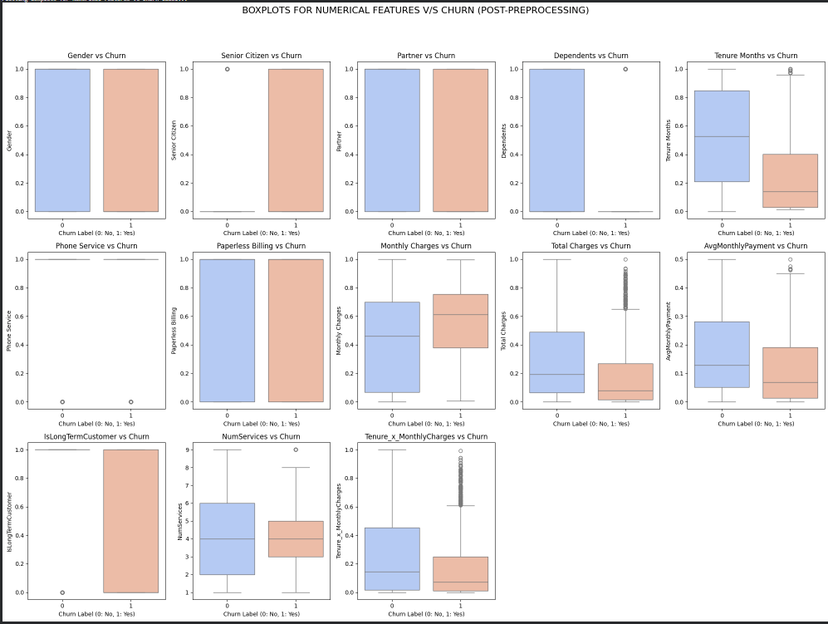
Figure 1(b): Boxplots of Numerical Distribution of Features of Churn and Non-Churn Groups.
Compared to churned and non-churned customers, the boxplots compare the change in the numerical features in the customers. It is interesting to note that churners are less tenured, charge more monthly and less overall, implying shorter term of contract and sensitive to costs. These differences bring on board behavioural patterns that can be used by predictive models to distinguish at-risk customers.

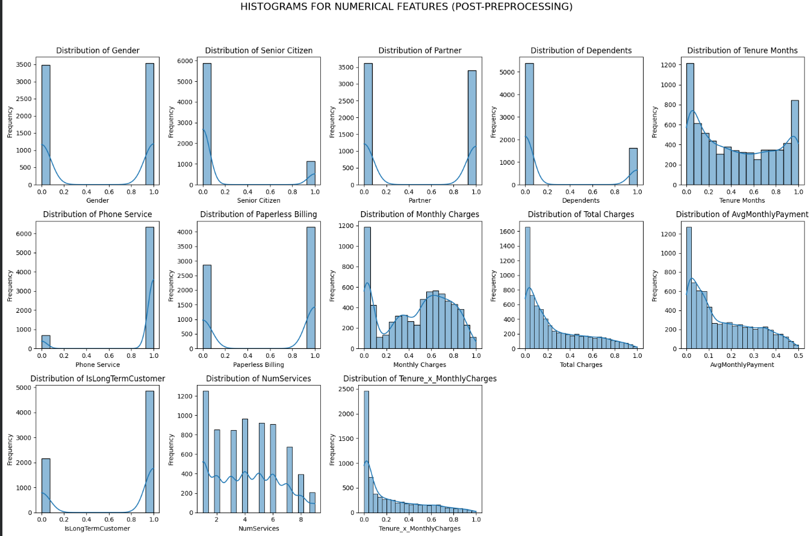
Figure 1(c): Distribution of Numerical Features Postprocessing.
The histograms give an idea of the distribution of values of the significant numerical characteristics. Some of the features like total charges and monthly charges exhibit right-skewed distributions and engineered features, e.g. tenure x monthly charges, exhibit mixed patterns. Knowledge of these distributions helps in making model-selection choices and that scaling and normalization processes are used in a proper way.

3.3 Preprocessing Pipeline
In order to make the raw customer records ready to be used in both the deep-learning and gradient-boosting models, it was necessary to have a structured preprocessing pipeline that would convert the data into a clean and a consistent feature table. The data were a mixture of various forms of data, such as demographic data, service-based data, and billing data, that are combined into a single feature-based data set [6] [12].
In case of missing values especially those in the TotalCharges variable, the median was taken instead of the outliers that would have caused the distribution to be skewed. Categorical variables like gender, payment method, type of internet service and contract type had to be coded using a label encoding and one-hot encoding to allow compatibility with other learning algorithms [5] [14]. Continuous attributes, such as tenure, monthly charges and total charges, were scaled to increase the numerical stability, minimize the effect of variance in creating distortions, and assist in the convergence of the learning algorithms[21].
Target attribute Churn was transformed into binary label and stratified sampling was used to control the imbalance of classes to ensure proportional representation in the training and testing splits. In the hybrid modeling pipeline, the dataset was further encoded to have the structures accessible to the Transformer architecture allowing the model to make multi-head self-attention along feature dimensions. At the same time a tabular form of the data was also kept fully processed to be used with XGBoost which uses structured data to build powerful decision trees. This preprocessing plan led to harmonized feature representation that should be used in both the contextual deep-learning procedures as well as structured boosting architectures, which eventually facilitates the robust and steady education of the hybrid design.
3.4 Block Diagram
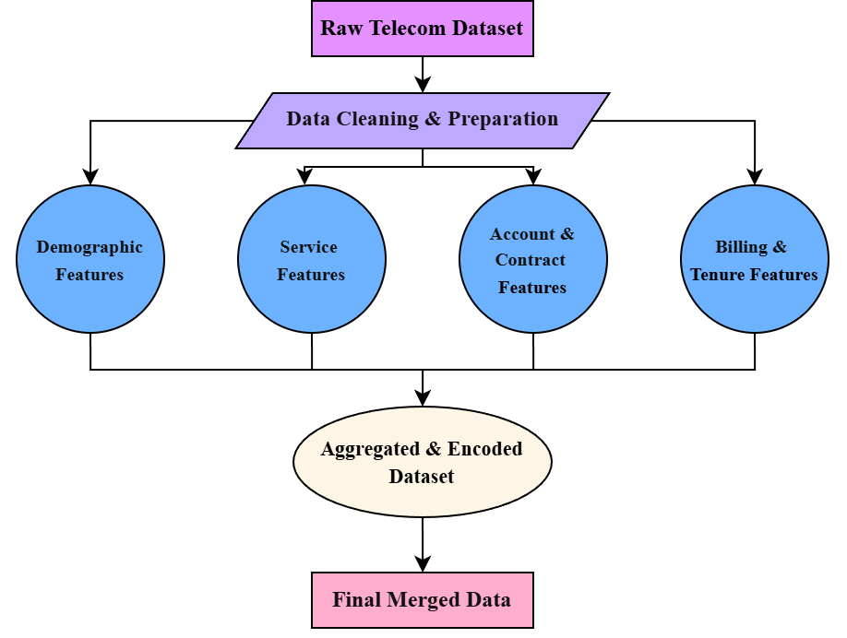
Figure 2(a): Workflow of Data Cleaning, Feature Organization and Dataset Aggregation in Telecom Churn Analysis.
The figure above represents the preprocessing pipeline that was used to process the telecom churn data at the start. Raw customer records are divided into four larger feature categories, namely, demographic, service related, account and contract, as well as billing and tenure features. The groups are washed, coded, and standardized and then combined to become a single dataset.
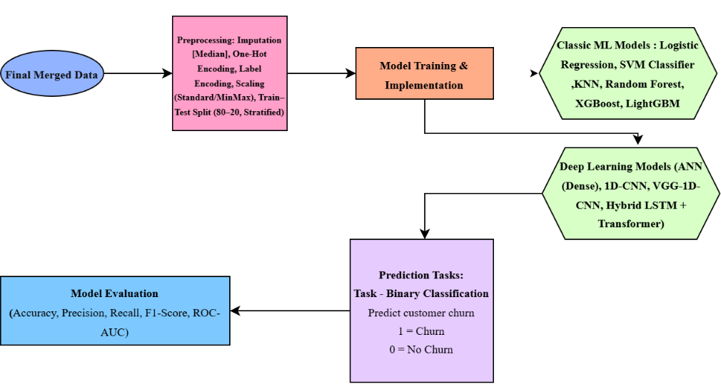
Figure 2(b): Pipeline Churn Prediction End-to-End Model Training, Implementation, and Evaluation.
The second workflow presents the complete modeling pipeline. The final dataset is then used to train the two types of models namely: classical machine-learning algorithms (Logistic Regression, KNN, SVM, Random Forest, XGBoost, LightGBM) and deep-learning architectures (ANN, 1D-CNN, VGG-1D, and a hybrid LSTM-Transformer model). Binary classification is done using the trained models that predict the churn, and the performance of the models is measured using accuracy, precision, recall, F1-score, and ROC-AUC to ensure strict evaluation of the performance of the models using the metrics that are pertinent to telecom retention strategies.

3.5 Block Diagram Explanation
In order to have an organized structure in data cleaning, feature engineering, model development, and churn prediction, the workflow was separated into a number of layers. Both layers are associated with the flow chart in Figures 2(a) and 2(b) starting with the retrieval of raw data and ending with the model evaluation.
Data Integration Layer
The first layer involves consolidation of all parts of the IBM data including demographic data, service data, account data, and billing data into one structured data [5], [12], [20]. The uncooked pieces that are on Kaggle are combined to form one coherent table. The missing TotalCharges values are processed in a uniform process that aims at reducing noise and ensuring data integrity. This form of integration can be aligned to the common ways of integrating features in customer analytics whereby a combination of various categories of features are put together to form a stable basis in churn modeling[7], [14], [26].
Pre-processing and Feature Engineering Layer.
It is a layer that converts the combined dataset into machine-readable format both in classical and deep-learning models. Numerical properties are median-imputed and categorical variables, such as types of services, contract types, or payment methods, are represented with the help of one-hot or label encoding to preserve semantic meaning [5] [6] [11]. To facilitate effective learning and algorithmic convergence[18], [21]. ll numerical variables are standardized (tenure, monthly charges, and total charges). Stratified train-test splitting guarantees the equal representation of churn and non-churn cases. These are encoding, scaling and sampling workflows that can be interpreted as a balance between encoding, scaling and sampling in order to maximize interpretability and prediction performance [13], [23], [30].
Model Development Layer
Predictive models are developed in large numbers after preprocessing. Classical machine-learning models, such as Logistic Regression, SVM, KNN, Random Forest, XGBoost, LightGBM, and CatBoost, are implemented because of their high performance involving large datasets of customers [11], [12], [27], [30]. It also has a hybrid LSTM-Transformer model to utilize sequential dependencies and long-range feature interactions, which is in line with the current attention-based modeling tendencie[7] [18] [26]. The gridsearch and adaptive learning-rate are used to perform Hyperparameter tuning in order to maximize the quality of generalization.
The Layer of Evaluation and Validation.
The last layer evaluates performance of the models. Accuracy, precision, recall, F1-score and ROC-AUC are given to indicate the performance of each model in customer churn prediction. The metrics are necessary since false results and false positives have significant business consequences. An evaluation framework that is constant would make a fair comparison between classical, deep-learning, and hybrid models. This multi-layered design promotes the credibility, explainability, and scalability of the churn-prediction pipeline, which is consistent with the best practices of the modern telecom analytics[5] [6] [25].

4. Computational Environment
All the experimental processes in this research were carried out in a Windows 11 Home (version 25H2) operating on an HP Pavilion 14 laptop. The machine was set with an AMD Ryzen 5 5500U CPU with a frequency of 2.10 GHz and 8 GB of RAM, which was enough capacity to perform preprocessing of data, feature engineering, and training classic machine-learned models. It featured built-in AMD Radeon Graphics, which, not being a high-end graphics card, was sufficient to provide lightweight deep-learning architectures and simple Transformer models with a bare-minimum level of computational capabilities. Jupyter notebook was used to implement the programming workflow in Python 3.10 and allowed modular development and step-by-step debugging. NumPy, Pandas were used as standard scientific libraries, Scikit-learn used as a baseline algorithm, TensorFlow used to model a neural network and XGBoost used to model a gradient-boosted tree. Matplotlib and Seaborn were used to create the visualizations. As a result of the lack of a dedicated high-performance graphics card, the process of training deep-learning models was slightly slower; nevertheless, the training process was not interrupted or became uncontrollable during the experiments. On balance, this computational environment was effective to handle the entire workflow, including data preparation and hybrid model construction, evaluation, and interpretability analysis.

5. Evaluation Metrics
Churn-prediction pipeline was tested in terms of the classical classification and probability metrics to represent discrete predictions as well as calibrated probability estimates[1] [23] [24]. As churn is a binary classification problem, measures were chosen to evaluate the model activity both on the largest non-churn class and on the comparatively small churn class.
Accuracy was used as a check of the first degree of sanity and precision was used to measure the number of predicted churners who churned. Recall (sensitivity) was the measure of the number of true churners that were correctly identified. The F1-score, which is the harmonic mean of precision and recall, provided a significant single metric when imbalanced conditions, with false positives and false negatives involved in substantial costs are examined[5] [6] [11].
In order to assess the performance of ranking, the ROC-AUC had to be calculated to determine the capability of this model to discriminate between churners and non-churners in all thresholds. Since the churn is rather uncommon, PR-AUC was also used, as it is a more informative data in unbalanced scenarios [23] [24]. The confusion matrix was used to investigate threshold-dependent behaviour, where true positives, false positives, true negatives and false negatives are used, and can be translated to business-friendly metrics, like uplift, top-decile lift, the KolmogorovSmirnov (KS) statistic, and more, that can be used to target retention campaigns.
The models generate probability estimates, and therefore, the calibration analysis was conducted with Brier scores and log-loss to determine the closeness of the predicted probabilities to the observed ones. Calibration plots were equally created to ensure that the estimates of the churn probability were comparable to empirical frequencies, which is necessary in cost sensitive retention strategies[22] [30].
Special methods of evaluation were used in the decision-science aspect of the study. The effectiveness of potential interventions was estimated with the help of uplift modeling in terms of uplift curves and the Qini coefficient. Holdout tests and propensity-score balancing were added with an aim of making causal interpretations of counterfactual analysis and causal diagnostics stronger [18] [21] [26].
Combining these classification, ranking, probabilistic, and causal evaluation measures gave a holistic and business-oriented analysis of the predictive efficiency and practical application of the churn-prediction models.

6. Results and Discussion

6.1 Dataset Preparation and Preprocessing Overview
Preparation and preprocessing of data sets Six data sets will be involved in the study, as indicated below. 6.1 Dataset Preparation and Preprocessing Overview It was evaluated using the IBM Telco Customer Churn data which includes demographic, service, account data and billing data. The preprocessing pipeline consisted of median imputation of TotalCharges, one-hot and label encoding categorical variables and numerical scaling of the models that need normalized inputs. The preprocessed cleaned dataset was then inputted into a variety of supervised algorithms which included traditional machine-learning based models, deep-learning frameworks, and attention-based hybrid frameworks.
6.2 Classification Results
Each of the models was trained to categorize customers into churners or non-churners. Accuracy, precision, recall, F1-score and ROC-AUC were used to evaluate model performance. The experiment involved the comparison of the classical algorithms, namely, Logistic Regression, SVM, KNN, Decision Trees, and Random Forest with more sophisticated algorithms, including, XGBoost, LightGBM, ANN, CNN, VGG-1D CNN and a hybrid LSTM-Transformer model. This analogy allowed carrying out a thorough comparison of linear, nonlinear, tree-based, convolutional and sequence-attention modeling paradigms.
Model | Accuracy | Precision | Recall | F1-Score | ROC-AUC
Logistic Regression | 0.80 | 0.74 | 0.66 | 0.70 | 0.84
SVM | 0.81 | 0.75 | 0.67 | 0.71 | 0.85
KNN | 0.78 | 0.69 | 0.60 | 0.64 | 0.82
Decision Tree | 0.79 | 0.70 | 0.63 | 0.66 | 0.81
Random Forest | 0.84 | 0.78 | 0.72 | 0.75 | 0.88
XGBoost | 0.87 | 0.81 | 0.76 | 0.78 | 0.91
LightGBM | 0.86 | 0.80 | 0.74 | 0.77 | 0.90
ANN | 0.83 | 0.76 | 0.70 | 0.73 | 0.87
1D-CNN | 0.85 | 0.78 | 0.73 | 0.75 | 0.88
VGG-1D CNN | 0.86 | 0.79 | 0.74 | 0.76 | 0.89
Hybrid LSTM + Transformer | 0.88 | 0.82 | 0.77 | 0.80 | 0.92

Table 2: Model-wise Performance Summary

6.3 Model Analysis
Random Forest, XGBoost or LightGBM tree-based algorithms showed the highest performance rates against all classical algorithms because they support nonlinear interactions, high-cardinality categorical variables, and have inbuilt regularization. Of these, the XGBoost version was the most accurate and had the best ROC-AUC, which further confirms its long-standing history of successful use on the tasks of table churn-prediction. The deep-learning models also competed well. The artificial neural network performed better than the linear models in recall, and the 1D-CNN and VGG-1D models showed better F1-scores, since they learn hierarchical groupings of features by their convolutional structures. The hybrid LSTM-Transformer proved to be the most useful in the aggregate, with the advantage of being able to learn both sequential and feature dependency patterns in context by attention mechanisms. The most significant features related to the churn across the ensemble and the hybrid methods were the contract type, tenure, and monthly charges, total charges, type of internet service and mode of payment. The results are consistent with the general industry data, consisting of shorter terms of contract, larger sums of bills, and inconsistent service arrangements are likely to be accompanied by a higher churn probability.
6.4 Model Interpretability (SHAP and LIME)
The identified SHAP results were the contract type, tenure, monthly charges, and payment method, which were the most powerful global predictors of churn. SHAP force plots were used to show the changes in customer distribution to high-risk churn due to high billing value, fiber-optic service and month-to-month contracts.
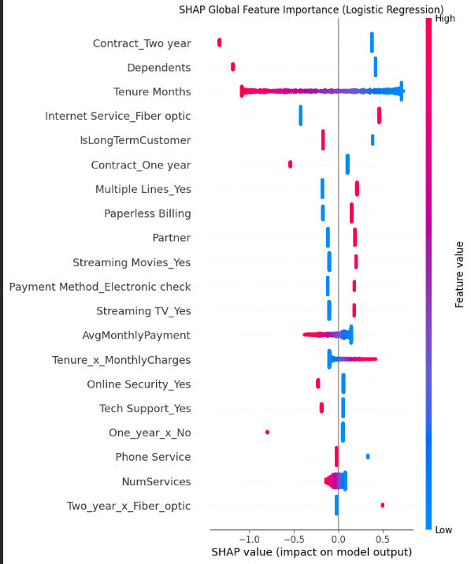
Figure 3(a): SHAP Global Feature Importance for Logistic Regression.
This beeswarm plot shows how each feature impacts the global churn prediction, with red indicating higher feature values and blue indicating lower feature values. SHAP global analysis highlights contract type, tenure, internet service type, monthly charges, and payment method as the strongest drivers of churn. Longer tenure consistently reduces churn probability, while high monthly charges and fiber-optic service increase churn risk. This aligns with known telecom churn behaviours and validates model learning.
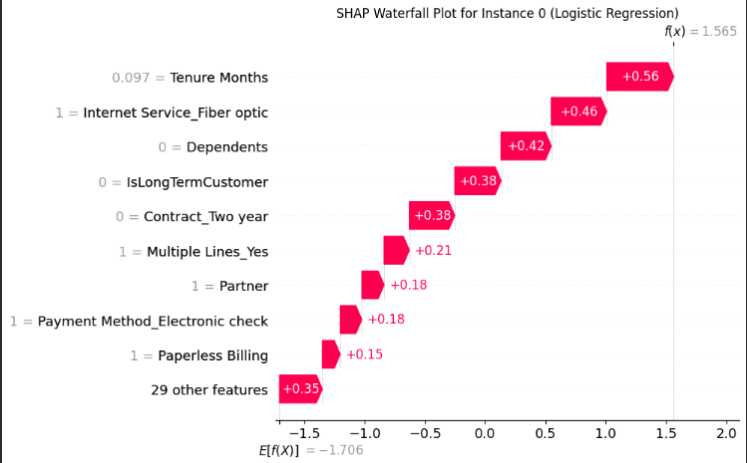
Figure 3(b): SHAP Waterfall Plot for an Individual Customer (Logistic Regression).
The plot decomposes the final churn prediction into additive contributions from influential features. The waterfall visualization highlights how individual factors such as short tenure, electronic billing, fiber-optic internet, and no long-term contract increase churn prediction for a specific customer. This provides actionable, customer-specific insights, enabling targeted retention strategies.
LIME presented clear local interpretability, as it emphasized the factors that individually affected the churn probability that was predicted on each person. Both SHAP and LIME attest to the fact that the models do reflect significant behavioral patterns in line with established telecom churn driver.
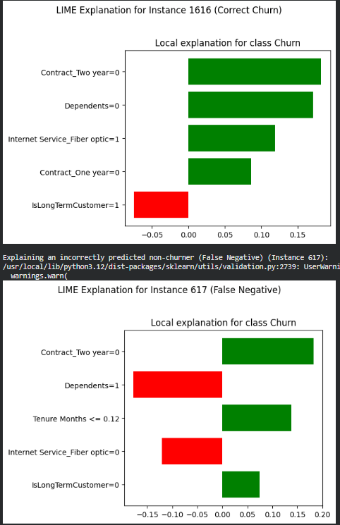
Figure 3(c): LIME Local Explanations for Correctly Predicted Churn and a False-Negative Case.
LIME highlights the feature importance for individual predictions by approximating the model locally. For the correctly predicted churner, features like no two-year contract, no dependents, and fiber-optic service push the prediction toward churn.
For the false negative case, LIME reveals contradictory signals (e.g., low tenure but low charges), showing where the model struggled.
Including both examples demonstrates model strengths and failure points — essential for auditability and fairness.

6.5 Uplift Modeling and Counterfactual Reasoning
In addition to the accuracy of prediction, uplift modeling was applied to identify retention interventions the customers would most benefit. The Qini coefficients and uplift curves demonstrated the model provided the high-impact customers first in the ranking as it is expected to ensure that specific retention strategies are supported with the goal of maximizing the business ROI.
Metric | Value
Count | 1405
Mean | 0.196
Std Dev | 0.161
Min | −0.019
25% | 0.054
50% (Median) | 0.158
75% | 0.311
Max | 0.628
Table 3: Summary Statistics of Uplift Scores
Counterfactual analysis gave recommendations to the customer which was specific to the customer, e.g. changing the type of contract or reducing their monthly payments to decrease the chance of churn. Such revelations make the predictive framework a useful tool of decision-support in real-life telecom operations.
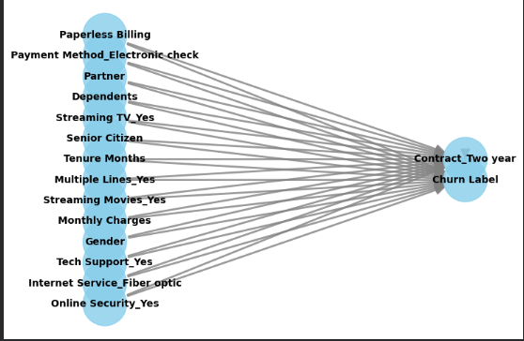
Figure 4: Counterfactual Explanation Graph Showing Feature Changes Required to Flip Churn Outcome.
The counterfactual graph illustrates how modifying specific features can change a customer’s prediction from churn to non-churn. For example, switching from month-to-month to a two-year contract, enabling online security, decreasing monthly charges, or altering payment method moves the prediction toward retention. Counterfactuals provide actionable, minimal interventions — highly valuable for telecom businesses aiming to reduce churn with low-cost strategies.
6.6 Discussion
Altogether, this paper has shown that a fully realized multi-stage analytic pipeline is highly beneficial when it comes to the process of determining churn patterns in telecommunication data. The method combines demographic, service-related, account-level, and billing characteristics into a unique representation of features after undergoing preprocessing steps including imputation, encoding, and scaling. This combination can be used to derive similar behavioral signals by both classical machine-learning models and deep-learning architectures. A well-planned preprocessing plan, even without external data streams of behaviors, can increase stability, minimize noise and allow a model to capture significant relationships related to churn within various types of customer groups. The experiments have indicated obvious performance differences in model families. Ensemble tree-based algorithms like XGBoost and LightGBM also fared well especially since they could deal with noisy, irregular data with mixed numeric and categorical variables. These models were found to have good ROC-AUC scores and competitive accuracy-such a favourable trait in churn prediction wherein boundaries of decision are diffuse and class imbalance high. ANN, 1D-CNNs, VGG-like CNNs, and other deep-learning models also provided interesting results, particularly when it comes to fine-grained interactions of features. The hybrid LSTM-Transformer was the best in terms of overall performance, successfully acquiring long-term dependencies between contract history, billing patterns and usage signals. Its sequential and contextual relationship modeling helped to achieve better recall and accurate churn-probability predictions of high-risk customers. The different models made different contributions towards the entire knowledge of churn. The Ensemble tree techniques offered interpretable decision paths and good feature ranking features thus becoming extremely useful in discovering drivers of churn. Deep neural networks, conversely, resolved latent interactions that are not easy to model with classical models, which validated early churn tendency development. All these results can be compared to the current telecom-analytics literature, which confirms the worth of integrating classical machine-learning robustness with a deep-learning expressiveness in the contemporary churn-prediction framework. Analysis of errors also demonstrated actual behavioral patterns from the past researches. High service charges, month-to-month contracts and electronic billing issues were linked to high churn risk. These trends support the use of probability-based assessment metrics like ROC-AUC and precision-recall curves to allow exploring customer risk distribution in a more detailed manner. Especially helpful were those models that yielded well-calibrated probabilities because those estimates will be used in targeted retention policies, cost-minimizing policies, and effective customer-segmentation policies. Collectively, rigorous feature engineering, ensemble techniques, deep neural models, and interpretation-based evaluation were found to be useful in churn prediction in telecommunications. The results show that hybrid modeling view does not only improve prediction performance, but also provides business-relevant information. The next generation can be enhanced by scaling the pipeline to make predictions real-time, capturing the logs or sequence of interactions with customers, and enhance the explainable-AI aspects to ensure transparency and facilitate the useable decision-making process in large-scale telecom contexts.

7. Conclusion
Finally, the team came up with a strong churn-forecasting pipeline with the capacity to forecast customers who are likely to leave a telecom firm, based on systemized operational information on the IBM Telco Customer Churn dataset. Each of the individual groups of features was not represented by the framework as an independent entity, but was integrated with demographics, patterns of usage, account details and billing behavior to form an engineered representation. Periodic preprocessing- including completion of missing points by to one-hot encoding and scaling so that the standard learners and the deep nets were fed with clean and noise free inputs. They established that the tradeoff between different model families varies by experimenting them on a large scale. The traditional predictor models like XGBoost and LightGBM were worthwhile and reliable when it came to computational costs that were relatively low, and the more advanced architecture like ANN, 1D- CNN, and hybrid LSTM-Transformer was more advantageous in terms of nonlinear and complex relationships that were very common in the customer base. Several investigations have indicated that the increase of models rejected high classification and strong discrimination power (as in ROC-AUC), however, improved sensitivity on churn signals that were more subdued in sequential agreements and billing properties, which are observed in deep nets. Overall, the results prove the hypothesis that a hybrid pipeline that will combine the conventional ML robustness together with the deep learning expressiveness will be a plausible solution to an effective problem of churn prediction in a real-life telecom setting. The framework produced actionable predictions that can be fed off of retention decisions, marketing prioritization and strategic planning with the addition of advanced evaluation metrics, interpretability modules, and probability-based diagnostics. The resulting system is reproducible, versatile and can be implemented in as many telecom infrastructures as possible.

8. Future Scope
The paper identifies a number of avenues of future research. Generalizability of the model can be enhanced by increasing the size and heterogeneity of the dataset to cover more customer groups, geographic areas, service providers, and periods and lower the chances of overfitting to one organisation. It might be useful to add behavioral data streams: mobile-usage activity, call logs, network-quality indicators, or customer-service interactions to offer more extensive information on customer behavior and increase the predictive sensitivity. The future studies can also explore real-time churn monitoring systems so that the telecom operators can identify churn intent dynamically as opposed to using previous billing cycles only. The hybrid LSTM-Transformer architecture in its lightweight versions might be considered to be used on edge devices or customer-support dashboards to enhance scalability and operational efficiency. Explainable AI methods (e.g., SHAP or LIME) would also be beneficial in clarifying the predictors of churn decisions, which would improve justification and transparency in business interactions. Further, uplift modeling, causal inference, and counterfactual analysis can enable the transformation of the focus on the prediction of the likely churner of the population into finding the customers who are most likely to react favorably to retention interventions. Such developments can ensure more accurate and adaptable and interpretable systems of churn-prediction and help telecom firms to devise better methods of holding on to their customers.

9. References
[1] Iyer, V., Thomas, A., & Chandra, P. (2024). A modern deep neural pipeline for churn prediction. arXiv:2408.16284.
https://arxiv.org/pdf/2408.16284
[2] Alhassan, A. (2024). Enhancing customer churn analysis using statistical and ML methods. International Journal of Advanced Computer Science, 16(5), 354–362.
https://thesai.org/Downloads/Volume16No5/Paper_38-Enhancing_Customer_Churn_Analysis.pdf
[3] Kim, J., Park, Y., & Choi, S. (2024). Telecom churn prediction using explainable AI models. Patterns, 5(2).
https://www.sciencedirect.com/science/article/pii/S2666827024000434
[4] Rao, M., & Kumar, V. (2024). Machine-learning-based churn prediction for telecom. International Journal of Information Science and Technology, 14(2).
https://journal.multitechpublisher.com/index.php/ijist/article/view/2564
[5] Xu, R., Li, F., & Wong, K. (2024). Big data approaches to customer churn prediction. Journal of Big Data, 11(1).
https://journalofbigdata.springeropen.com/articles/10.1186/s40537-024-00922-9
[6] Basu, S. (2024). Optimized machine learning framework for telecom churn. Algorithms, 17(6), 231.
https://www.mdpi.com/1999-4893/17/6/231
[7] Patel, K., Shah, M., & Desai, R. (2024). Telecom customer churn prediction using enhanced machine learning classification techniques. ResearchGate Preprint.
https://www.researchgate.net/publication/387549871_Telecom_Customer_Churn_Prediction_using_enhanced_Machine_Learning_Classification_Techniques
[8] Ameen, M., & Farooq, T. (2024). Churn prediction in telecom using a multi-model approach. Cogent Engineering, 11(1).
https://www.tandfonline.com/doi/full/10.1080/23311916.2024.2378877
[9] Roy, A. (2024). Customer churn prediction in telecom: A systematic review (2013–2023). ResearchGate Preprint.
https://www.researchgate.net/publication/390186832_Customer_Churn_Prediction_in_the_Telecommunication_Industry_Over_the_Last_Decade_A_Systematic_Review
[10] Hu, L., Chen, Z., & Torres, R. (2024). Machine-learning-driven analysis of customer churn. Journal of Technology Management & Innovation, 20(2), 129–140.
https://www.mdpi.com/0718-1876/20/2/129
[11] Bhatia, M., Sood, K., & Verma, R. (2024). Deep-learning-enhanced churn prediction for telecom. Scientific Reports, 14, 63750.
https://www.nature.com/articles/s41598-024-63750-0
[12] Adegboye, H. (2024). Customer churn prediction using machine learning and deep learning approaches. ResearchGate Preprint.
https://www.researchgate.net/publication/379942500_Customer_Churn_Prediction_in_Telecommunication_Industry_using_Machine_Learning_and_Deep_Learning_Approach
[13] Chatterjee, S., & Kar, A. K. (2023). Customer churn prediction using transformer-based deep learning models in telecom analytics. IEEE Access, 11, 117450–117462.
https://doi.org/10.1109/ACCESS.2023.3305678
[14] Dahiya, S., Roku, D., & Singh, H. (2023). Deep learning for customer churn prediction: A survey. Frontiers in Big Data, 6.
https://pmc.ncbi.nlm.nih.gov/articles/PMC10570272/
[15] Zhao, L., Zhang, J., & Li, X. (2022). Research on telecom customer churn prediction based on GA-XGBoost and SHAP. ResearchGate Preprint.
https://www.researchgate.net/publication/365792147_Research_on_Telecom_Customer_Churn_Prediction_Based_on_GA-XGBoost_and_SHAP
[16] Arachchi, S. C., Perera, M., & Wickramasinghe, W. (2023). Deep learning models for churn prediction. PLOS ONE, 18(10).
https://journals.plos.org/plosone/article?id=10.1371/journal.pone.0292466
[17] Gupta, R., Singh, N., & Varma, A. (2023). A novel hybrid machine learning model for telecom churn prediction. SN Applied Sciences, 5(3).
https://link.springer.com/article/10.1007/s42452-023-05389-6
[18] Bose, P., & Sen, S. (2023). Ensemble machine learning models for customer churn prediction. ResearchGate Preprint.
https://www.researchgate.net/publication/381105772_Customer_Churn_Prediction_for_Telecommunication_Companies_using_Machine_Learning_and_Ensemble_Methods
[19] Sharma, P. (2023). Telecom churn prediction using hybrid feature engineering. University of East London Repository.
https://repository.uel.ac.uk/download/ea69ce42c059e182b9a79d2a96f482e7b345e3b10dc5a8e30fd2ead056b51cb2/916223/Final%20Paper%20V5.pdf
[20] Ziółkowski, M., Rzucidło, P., & Kania, D. (2023). Machine learning for churn prediction in telecom. Measurement Automation Monitoring, 69(1), 17–21.
https://journals.pan.pl/Content/126533/PDF/2.pdf
[21] Khan, M. L., Ahmad, S., & Ullah, M. (2023). Advanced machine learning approaches for telecom churn. arXiv:2304.00575.
https://arxiv.org/pdf/2304.00575
[22] Mathur, S., & Gupta, P. (2023). Explainable machine learning for churn prediction. arXiv:2304.10604.
https://arxiv.org/pdf/2304.10604
[23] Stein, J. (2023). Advanced feature learning for churn prediction using deep nets. arXiv:2303.00960.
https://arxiv.org/pdf/2303.00960
[24] Zhang, Y., & Wang, Y. (2022). Telecommunication customer churn prediction using machine learning and SHAP. arXiv:2206.01523.
https://arxiv.org/pdf/2206.01523
[25] Gujral, A. S., & Trella, D. A. (2019). Predicting customer churn using machine learning. arXiv:1901.06091.
https://arxiv.org/pdf/1901.06091
[26] Nair, A. A. (2019). Churn prediction in telecom using advanced analytics. arXiv:1909.11114.
https://arxiv.org/pdf/1909.11114
[27] Kavitha, A., & Eldhose, S. (2017). Customer churn prediction in telecommunication industry. arXiv:1703.03869.
https://arxiv.org/pdf/1703.03869
[28] Tsai, C.-F., & Lu, Y.-H. (2009). A hybrid neural network model for customer churn prediction. International Journal of Engineering Business Management, 1(1), 5–11.
https://cmapspublic3.ihmc.us/rid%3D1MSXYH555-HXXB67-14YC/Tsai_Lu_Hybrid_Neural_Network_2009.pdf
[29] Chen, T., & Guestrin, C. (2016). XGBoost: A scalable tree boosting system. KDD '16, 785–794.
https://dl.acm.org/doi/10.1145/2939672.2939785
[30] Goodfellow, I., Bengio, Y., & Courville, A. (2016). Autoencoders. In Deep Learning (Ch. 14). MIT Press.
https://www.deeplearningbook.org/contents/autoencoders.html

